Diamond-Shaped Multi-Agent AML System with Advanced Graph and Self-Supervised Learning

Submitted By: Sadhna Mall (GenAI Team)
Pranav Srihas Allu (GenAI Team)

- Executive Summary
Financial institutions face increasing challenges in detecting sophisticated money laundering, loan fraud, and identity fraud patterns. Traditional rule-based systems are limited in scope and unable to capture complex, relational patterns in financial data. This paper proposes a diamond-shaped multi-agent AML system leveraging state-of-the-art AI techniques, including BYOL and SDNL for self-supervised embeddings, GAT and GNN for graph-based sub-agent analysis, and GPT-4 for virtual assistant interaction.
The system integrates AML transaction, KYC, loan, and deposit datasets from Kaggle. The King Agent (FinBERT + SDNL embeddings) orchestrates task routing to four specialized sub-agents: Transaction Agent (GAT/GNN), Loan Agent (GNN), KYC Agent (Decision Tree + Rules), and Deposit Agent (GAT/GNN). Outputs are aggregated by a Risk Decision Agent (Neural Combiner / Deep Ensemble) to generate a unified risk score. A Virtual Assistant (GPT-4) provides real-time, interpretable insights to users. This architecture demonstrates the power of modern AI in AML, capturing complex relationships, improving detection accuracy, and enabling intelligent customer interaction.

- Introduction
Anti-Money Laundering (AML) compliance is a critical and evolving challenge for financial institutions. Conventional systems rely heavily on static rules and threshold-based approaches, which:
- Fail to detect sophisticated fraudulent patterns.
- Generate high false positives.
- Analyze datasets in isolation, missing cross-domain relationships.
Recent advances in self-supervised learning (BYOL, SDNL) and graph neural networks (GAT, GNN) provide opportunities to model complex relational structures in financial data. This paper introduces a diamond-shaped multi-agent architecture that integrates these modern techniques, combining specialized sub-agents, a central King Agent, a deep ensemble risk aggregator, and a virtual assistant for user interaction.

- Problem Statement
Current AML solutions suffer from:
- Limited relational reasoning: Cannot detect circular or linked fraudulent transactions.
- Fragmented analysis: Transaction, loan, KYC, and deposit datasets are treated separately.
- Poor transparency: Customers and investigators lack clear insights into flagged activities.
- Scalability constraints: Traditional models struggle with large, complex datasets.
A more intelligent, data-driven, and network-aware system is required for modern AML risk detection.

- Proposed Solution
The proposed solution is a diamond-shaped multi-agent system integrating advanced AI techniques:
- King Agent (FinBERT + SDNL embeddings):
  - Ingests all datasets.
  - Generates robust self-supervised embeddings via SDNL/BYOL.
  - Routes tasks to the appropriate sub-agent based on data type and context.
- Sub-Agents:
  - Transaction Agent (GAT/GNN): Detects fraudulent patterns in account transaction networks.
  - Loan Agent (GNN): Identifies suspicious loans and linked applications.
  - KYC Agent (Decision Tree + Rules): Verifies identity and compliance of customers.
  - Deposit Agent (GAT/GNN): Detects anomalous deposit patterns and circular transactions.
- Risk Decision Agent (Neural Combiner / Deep Ensemble): Aggregates sub-agent outputs into a unified AML risk score.
- Virtual Assistant (GPT-4): Provides interpretable, real-time explanations for flagged transactions and AML risks.

- Datasets and Preprocessing
Datasets:
- AML Transaction Dataset: Transactions with fraud labels.
- KYC Dataset: Customer verification and identity attributes.
- Loan Dataset: Loan applications with risk indicators.
- Deposit Dataset: Deposit records with temporal and network attributes.
Preprocessing Steps:
- Data Cleaning: Remove duplicates, impute missing values.
- Feature Engineering: Extract graph structures for transaction/deposit networks.
- Graph Construction: Build node-edge representations for GAT/GNN.
- Self-Supervised Embeddings: BYOL/SDNL applied to pretrain embeddings for King Agent routing and sub-agent inputs.
- Train-Test Split: Standard splits and cross-validation for evaluation.

- System Architecture

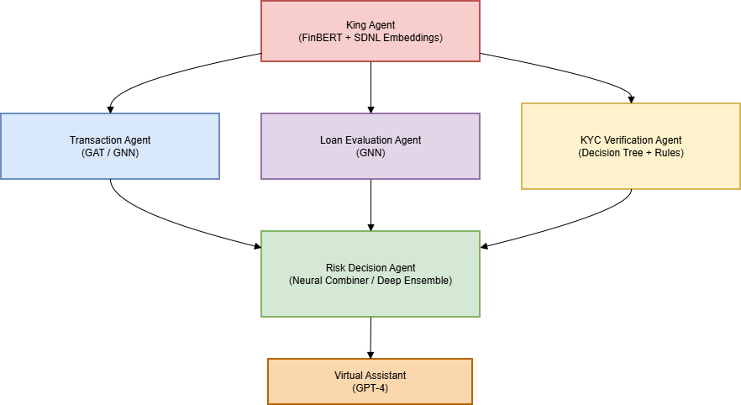

t the center of this architecture lies the King Agent, built using FinBERT for contextual financial understanding and SDNL embeddings for self-supervised representation learning. The King Agent acts as the controller — it receives multi-domain datasets, analyzes them, and dynamically routes each data type to the most suitable sub-agent.
The framework includes four specialized sub-agents, each focusing on a unique domain:
- Transaction Agent (GAT/GNN): Detects complex transactional relationships and suspicious network patterns among accounts.
- Loan Agent (GNN): Evaluates interconnected loan applications to identify potential collusion or synthetic identities.
- Deposit Agent (GAT/GNN): Monitors circular or anomalous deposit flows using graph-based relational insights.
- KYC Agent (Decision Tree + Rule-Based System): Performs identity verification and compliance checks on structured customer data.
The outputs from all sub-agents are aggregated by a Risk Decision Agent, powered by a Neural Combiner (Deep Ensemble). This module synthesizes insights across domains to generate a unified AML risk score — reflecting both individual and relational risk patterns.
Finally, the system is enhanced with a Virtual Assistant built on GPT-4, which provides explainable, real-time communication to compliance officers and customers. It can answer queries, explain model reasoning, and summarize the rationale behind flagged transactions or accounts — bridging the gap between AI insights and human understanding.
- King Agent: Routes tasks intelligently using SDNL/BYOL embeddings.
- Sub-Agents: Specialized graph-based analysis for relational data.
- Risk Decision Agent: Combines outputs from sub-agents into a single risk score.
- Virtual Assistant: Customer-facing interface for explanations and queries.

- Methodology

- Task Routing: King Agent processes incoming records and selects appropriate sub-agents.
- Sub-Agent Analysis:
- Transaction Agent (GAT/GNN) models relational patterns between accounts.
- Loan Agent (GNN) detects suspiciously connected loans.
- KYC Agent (Decision Tree + Rules) validates customer identity.
- Deposit Agent (GAT/GNN) detects anomalous deposits and circular flows.
- Risk Aggregation: Neural Combiner merges outputs into a single AML risk score.
- Customer Interaction: Virtual Assistant (GPT-4) interprets risk scores and provides natural language explanations.

- Results and Evaluation
• Metrics: Accuracy, Precision, Recall, F1-score, False Positive Rate (FPR).
• Expected Outcomes:
- Improved detection of relational and networked fraud patterns.
- Reduced false positives compared to traditional AML systems.
- Demonstrates capability of self-supervised embeddings and graph neural networks in AML detection.
- Business Impact
Advanced Fraud Detection: Captures complex, multi-domain patterns.
Regulatory Advantage: Supports cutting-edge AI research in AML.
Customer Transparency: Virtual Assistant enhances trust and engagement.
Research Contribution: Demonstrates novel use of BYOL/SDNL + GNN in financial risk analysis.
- Future Enhancements
- • Integration of multi-modal data (emails, documents) for fraud detection.
- • Real-time streaming implementation of transaction graphs.
- • Multi-lingual Virtual Assistant with context memory.
- • Incorporation of explainable AI techniques for regulatory review.

  - Conclusion
This white paper presents a research-oriented, diamond-shaped multi-agent AML system leveraging BYOL, SDNL, GAT, GNN, and GPT-4. The architecture captures complex relational patterns, integrates multi-domain datasets, and enables intelligent risk scoring and customer interaction. The system demonstrates the potential of modern AI techniques in anti-money laundering research.

  - References
Kaggle AML Transaction Dataset: https://www.kaggle.com
Kaggle Loan Dataset: https://www.kaggle.com
Kaggle KYC Dataset: https://www.kaggle.com
Y. Huang et al., “FinBERT: Financial Sentiment Analysis,” arXiv, 2020

Chen, T., & Guestrin, C. “XGBoost: A Scalable Tree Boosting System,” KDD, 2016
Caron et al., “BYOL: Bootstrap Your Own Latent,” NeurIPS, 2020
Veličković et al., “Graph Attention Networks (GAT),” ICLR, 2018
Liu et al., “SDNL: Self-Discriminative Network Learning,” NeurIPS, 2022

